Adrien Clay

Springboard Data Science

10/27/2020

Big Mountain Resort Findings

Big Mountain Resort is facing a dilemma regarding ticket pricing. Through a very careful balance of operational costs and feature availability, Big Mountain Resort has priced the tickets to their resort as they saw fit. The resort itself sits in a very advantageous place in regards to what it offers versus how much it charges, as it sits on the high end of many features that some resorts (who charge more in some cases) don’t even come close to. An example of some of these features include vertical drop, total acres covered by snow, the number of fast quads available on the resort, total number of runs, longest runs, and skiable terrain area. This is an interesting juxtaposition compared to their place in the ticket pricing market when placed next to other resorts, as they fall much closer to the middle, but not quite. 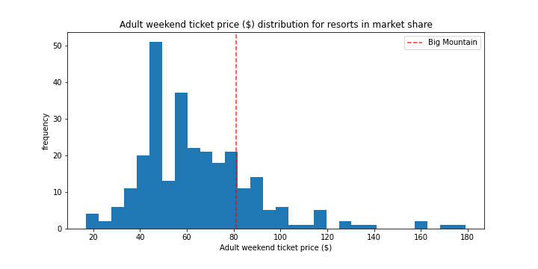

As you can see from the histogram above, the ticket price for Big Mountain compared to all resorts in the nation amounts to around $81. This is an interesting juxtaposition compared to something like Mammoth Mountain Ski Resort in Sierra Nevada, California which ultimately touts no greater than a 14% increase in ski-able area yet charges roughly 200% the price that Big Mountain Resort does. This is likely an indication that Big Mountain Resort is likely undercharging for its services and available amenities. Regardless, it appears that there is a somewhat strong correlation between a few different features in the data and the Adult Weekend ticket price. A heatmap (correlation chart) is shown below:



According to this heatmap, some of the features that are more highly correlated with AdultWeekend ticket price are things like Fast Quad availability, vertical drop, number of runs, and snow making acre coverage. While not all of these features will turn out to have an effect on our predict ticket price, one in particular will – Vertical drop.

Of our modeling scenarios, the only one that turned out to be of value for predicting ticket price outcome was ultimately vertical drop. The following scenarios were proposed as viable methods to increase value and/or decrease operational costs at Big Mountain Resort:

1. Permanently closing up to ten of the least used runs.
2. Increase the vertical drop by 150ft by expanding downward on the mountain (This will require the installation of a chair lift.)
3. Same as option two but adding 2 acres of snow making cover.
4. Increase the longest run by .2 mile to boast 3.5 total miles in length. This will require additional snow making coverage of 4 acres.

When utilizing these scenarios to make predictions, it turns out that option three and four did not bear much weight as far as changing the predicted ticket price. The two important features came down to run closure, and vertical drop. When increasing the vertical drop by 150ft total, our model predicted an increase of $1.99 in ticket price, which would ultimately amount to a revenue increase upwards of 3 million USD per year. While this sounds amazing, it would also be important to consider the cost of installing and operating a new lift to make this viable. Finally, by closing the least used run, this would not affect ticket prices but anything beyond that would result in a decrease in ticket price. Ultimately, it would be a good idea for Big Mountain Resort to close one run and increase the vertical drop by 150 ft. This would allow them to supplement the cost of the one they are closing with the new one that would allow for vertical drop expansion, and ultimately raise the ticket price.